Yes
CAN YOU TAKE CARE?
INJURED / WOUNDED
PERFORM INICIAL ASSESSMENT

SECURE THE AREA

No

PROVIDE FIRST AID
REPORT TO MANAGER

MEDEVAC

TRANSPORT
TO HOSPITAL

REPORT TO MANAGER

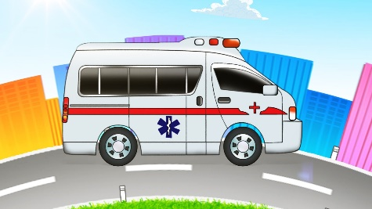

INFORM TO INSTITUTION OF OCCUPATIONAL HAZARDS

MEDICAL ATTENTION IN HOSPITAL

PERFORM ACCIDENT REPORT

Emergency numbers
NAME | PHONE
HOSPITAL
INSTITUTION OF OCCUPATIONAL HAZARDS
AMBULANCES
RED CROSS
FIRE
LOCAL POLICE

INJURED / WOUNDED
CAN YOU TAKE CARE?
NO |  |  | YES
Report to Manager |  |  | Secure the area
Transport to Hospital |  |  | Perform initial assessment
Medical attention in Hospital |  |  | Provide First Aid
 |  |  | Report to Manager
PERFORM ACCIDENT REPORT
Inform to Institution of Occupational Hazards

